**Table of Contents**

1. **Goals and Objectives:**

In today’s competitive IT industry, Rakez needs to leverage the Data Strategy Program identify Data gaps across various domains and sources. Rakez looking for options to improve data quality management and data enrichment practices with advanced BI analytical capabilities for improved productivity.

1. Identify the relevant key analytical use cases that need to be prioritized and implemented
2. Identify the various management gaps by assessing and understanding the

organization’s data maturity

1. Develop a roadmap/plan to implement the strategy
2. **IT Needs:**
3. Deployed Infrastructure Analysis

We’ll design an infrastructure or leverage the existing tools for you that will let you take charge of your Data Maturity, IT costs, boost your system security, and help your business better serve your customers.

1. Strengthened Data Management

We’ll assess your current data landscape and implement the best data governance activities by suggesting best available industry tools and services to make sure that it will meet business standards and roles.

We'll offer ongoing infrastructure and Data management services. We take responsibility for the end-to-end function, which gives you peace of mind and frees up time and energy to grow your business.

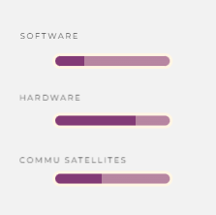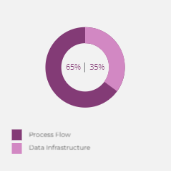

1. **Our Methodologies:**
2. **Customized Infrastructure Creation and Development**

A customized IT infrastructure puts you in the best position for future growth. Exalogic will start with a comprehensive review of your current business processes and application portfolio. We'll develop the strategy to implement an infrastructure that reduces costs, boosts productivity, and accomplishes your unique goals.

1. **Data Governance Practices**

Exalogic will analyze Rakez current data management process and identify any areas that can be improved/enhanced. Then we will design and deploy new data governance principles with key Business Stakeholders specially designed to integrate seamlessly into Rakez IT infrastructure.

1. **Ongoing Infrastructure Management**

After designing the roadmap and Data Management Strategy we will start integrating them into Rakez infrastructure. This will free up time to focus on scaling Rakez business without worrying about technical details along the way.

1. **Use metrics to measure progress**

It is critical to measure progress and display the success of your data governance program. Plan on defining your metrics before you start introducing data polices. This lets you set a starting point based on your current data management practices.

1. **By defining data governance team roles**

Exalogic will help in defining the data governance roles of team members across your organization creates the framework on which a governance plan runs. Defining roles across Data owners and Data users is important for maintaining Data governance best practices.

1. **Data Maturity assessment**

Evaluating the effectiveness of your organization’s data policies, processes, and personnel. An especially thorough assessment can even highlight weaknesses in the minutiae of your Data Management and handling practices, helping you zero-in areas ready for improvement. Will closely work on these areas to minimize the gaps in order to implement best data maturity practices.

1. **Your Investment:**

In today’s competitive IT industry, Exalogic needs to leverage the latest technology to expand and protect its business without breaking the bank. Rakez needs a comprehensive infrastructure and Data Management solution to:

|  |  |  |
| --- | --- | --- |
|  | SERVICE | COST |
| 1 | Infrastructure analysis and improvement | $ |
| 2 | Data Management Strategy Imp. | $ |
| 3 | Data Strategy and Implementation Roadmap | $ |

1. **Project Timelines**
2. **Discover:**

Analysis of Rakez current IT infrastructure, security measures, and business goals.

1. **Upgraded Infrastructure Design and Data Management Practices**

Comprehensive strategy development to upgrade infrastructure and Data Management Practices to improve efficiency, minimize costs, and protect business against threats.

1. **Infrastructure Management**

Will continue to monitor Rakez infrastructure, track its performance, and provide timely solutions should anything go wrong.

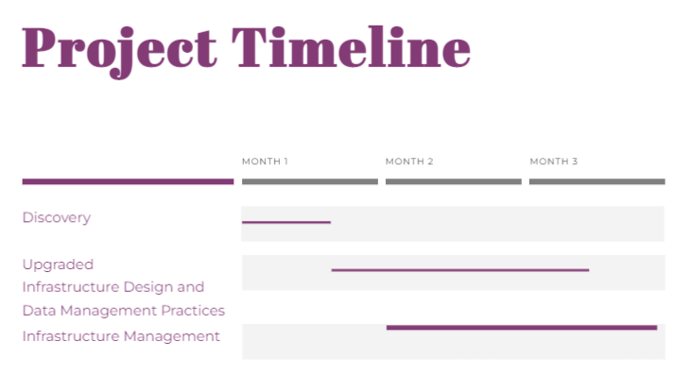

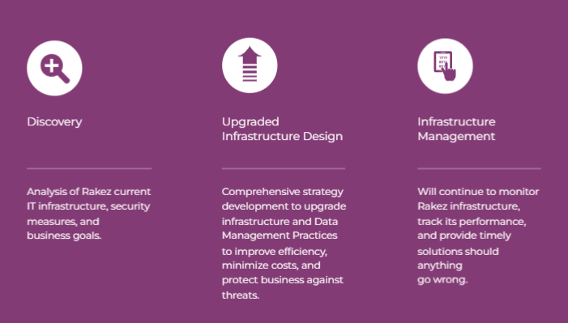

**Project Approach, Deliverables & Exit Criteria Summary**

|  |  |  |  |
| --- | --- | --- | --- |
| S.no | Project Phase | Exit Criteria | Deliverables |
| 1 | Project Discovery Phase |  | Pre-requisites for requirement workshop  Kick off meeting |
| 2 | Requirement Gathering & Design | Signed off Business requirement document. | BRD to be delivered  Project management plan and project charter |
| 3 | Upgradation of Infrastructure Design based on recommendations | Signed of Specifications  Signed off use cases  Unit testing complete.  All the technical objects delivered | Technical Specifications  Configured and Unit Tested solution  UT result document  Technical objects |
| 4 | Build and development of Data Governance Practices with Rakez team | Signed of Specifications  Unit testing complete. | New Data Governance practices to be implemented along with Rakez IT team  SPOC person from Rakez team to be included for every data governance policy discussions. |
| 5 | System Integration Testing (SIT) | Signed off SIT test results  Signed off Test Data | SIT results in the form of defects logged.  Data for testing in Quality Assurance environment will be provided by Customer in predefined format |
| 6 | User Acceptance Testing (UAT) | Signoff for UAT with zero defects  Go Decision by Steering Committee | UAT results  UAT Defect Log  Finalized Cutover/Release Management plan |
| 7 | Cutover and Go-Live | All technical objects moved to production system with the corresponding technical configurations as well | Cutover plan  System Go-Live |
| 8 | Hypercare | Zero open Severity 1 or 2 defects | Transition of support from Incture delivery team to the support team.  KT documents |

|  |  |  |  |  |  |  |  |  |  |  |  |  |
| --- | --- | --- | --- | --- | --- | --- | --- | --- | --- | --- | --- | --- |
| Week | WK1 | WK2 | WK3 | WK4 | WK5 | WK6 | WK7 | WK8 | WK9 | WK10 | WK11 | WK12 |
| Discovery Phase & Requirement Analysis |  |  |  |  |  |  |  |  |  |  |  |  |
| Upgradation of Infrastructure design and data governance design |  |  |  |  |  |  |  |  |  |  |  |  |
| Infrastructure Management |  |  |  |  |  |  |  |  |  |  |  |  |
| UAT |  |  |  |  |  |  |  |  |  |  |  |  |
| Hyper Care & Handover |  |  |  |  |  |  |  |  |  |  |  |  |
|  |  |  |  | First Drop |  |  |  | Second Drop |  |  |  | Third Drop |